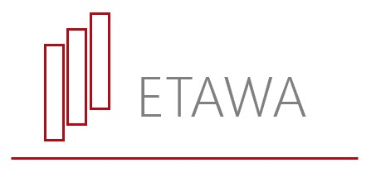

HASS Week 2024 Economics Cartoon Competition
Parent consent form

School name: __________________________________________________________________________

I give my child/ward permission to enter the Economics Teachers’ Association HASS Week 2024 Economics Creative Competition and accept the Terms and Conditions of the Competition.

Name of student: ______________________________________________________

Signature of parent/guardian: ______________________________________________________

Print name of parent/guardian: ______________________________________________________

Date: ___________________

Contact email: ______________________________________________________

